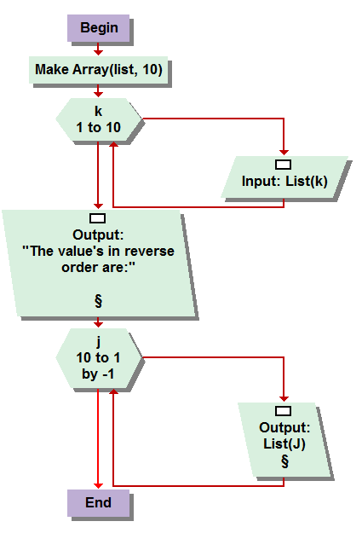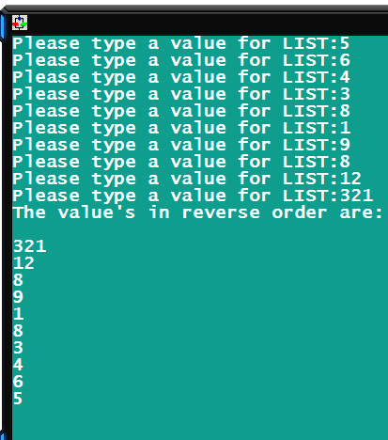

5.1  
This one was pretty easy. Input with an array named list, using a for loop inputing elements in order one to ten, then out putting them using a for loop counting backwards from ten to one outputting each element so forth.

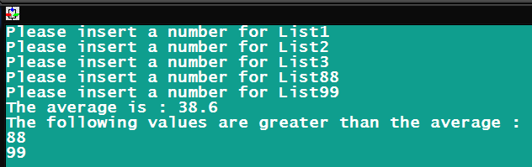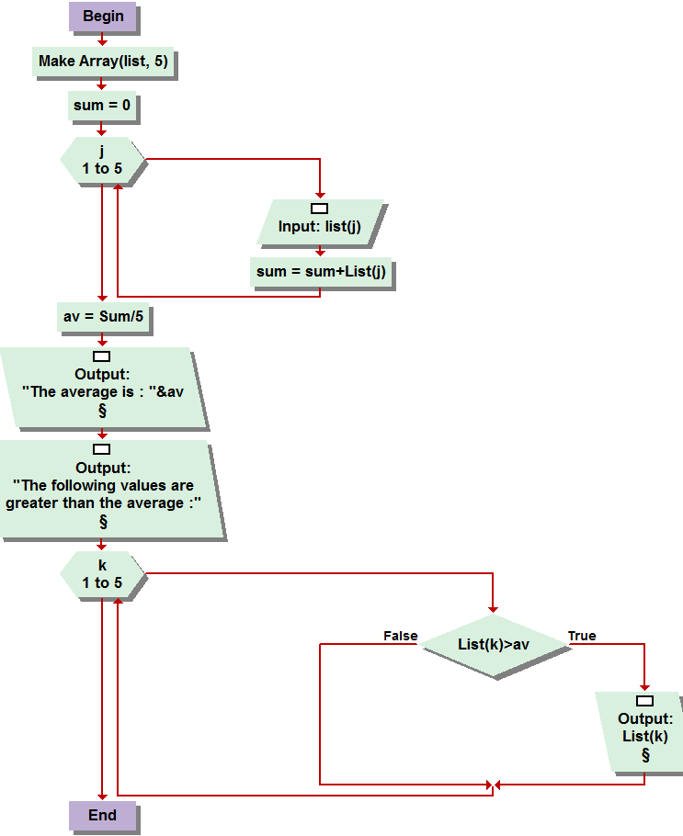

5.2  
Basic function of an average. Create an array, input five values via for loop, simultaneously adding their values to a variable named sum. Then divide sum by five, for each value, out put the average, then an output for the greater than average figures, which is determined by a conditional test on the list element, through a for loop, and if it is greater then the average, it is out putted.

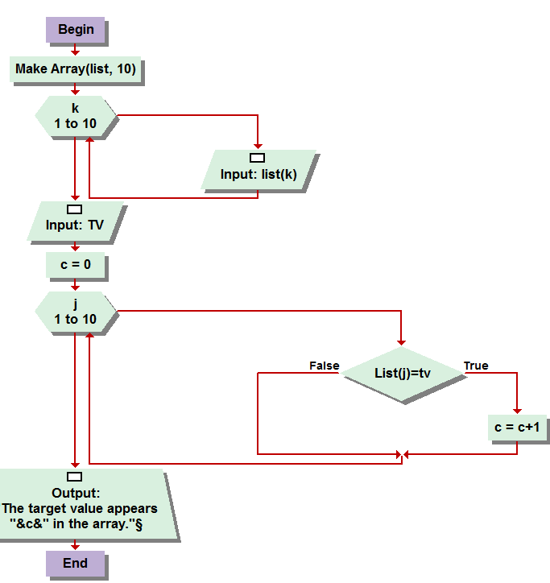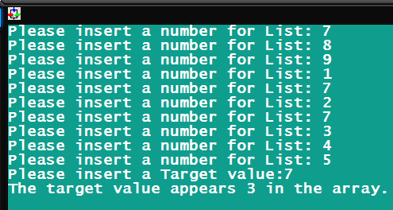

5.3 Make array, use a for loop for the input of the for loop, in this case a for loop 1 to ten, then inputting to the corresponding element. After that, the program prompts you to input a target value, “tv”, and you create a counter , or “c.” Another for loop, J, will run ten times, testing each element of the array to see if their value is equal to the target value being seeked out by the user. Each time the loop finds a match via the test condition, the counter is increased by one. Finally, an output statement displays the number of time the target value occurs, by displaying the counter value.

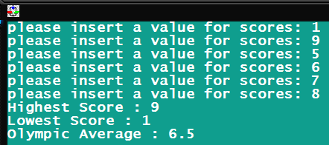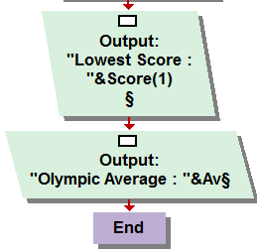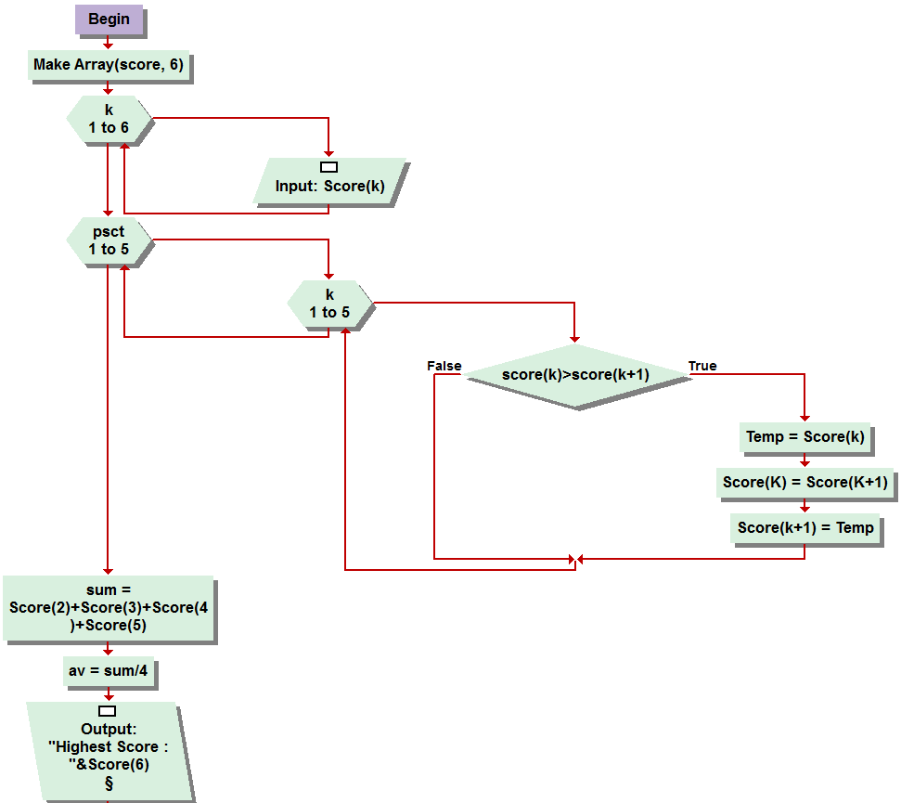

5.8  
wow almost forgot to type this one up! So you use the for loop for the input of the elements in the array created and named score. Then u use the bubble sort as demonstrated in the book to put them in the correct order of lowest to highest. My coding for the average is a little redundant but it gets the job done, score 2 3 4 5 all added together and divided by four for the average. Finally, out putting the highest and lowest scores in the array, after being sorted by bubble sort, are elements 1 and 6, and not used in finding the average.

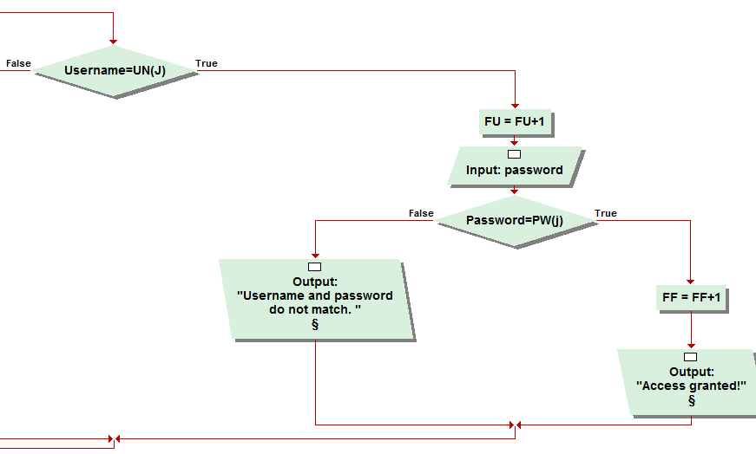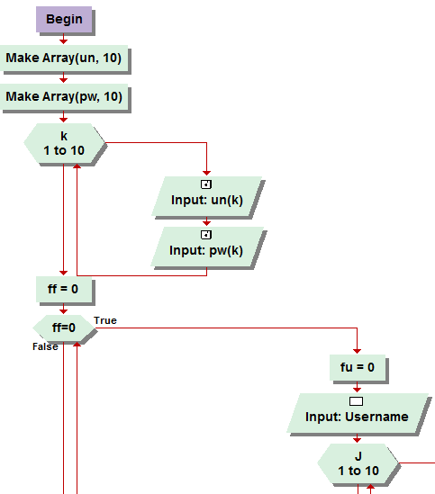

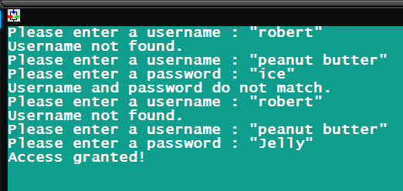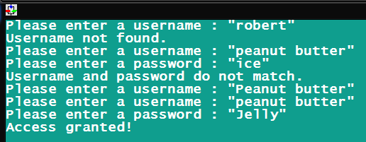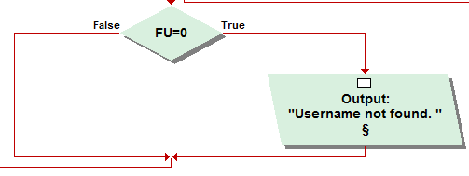

**OKAY SO I FINALLY FIGURED THIS ONE OUT….!!! WOOO HOOOO HALIELUGIA .**Anway back to reality.   
SO this one took me the most time and headache out of ANYTHING and EVERYTHING we have learned and programmed so far combined. Seriously, and not to brag, but I thought, before this, that I was really catching on quick. But I got it. The problem I initially had was the reprompting without a bunch of , 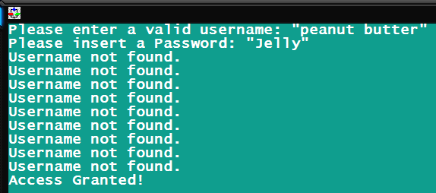 This was my biggest problem. The looping and keeping it clear and concise with proper re-prompting. But finally I just buckled down, since like yesterday afternoon, and tested and tested and corrected mistakes till I finally got it. So you create the array, with the user name and password files, which took me a few read overs in the book to fully comprehend how it all worked but I got and could even envision applying it 3 or 4 dimensional arrays. Then the found flag = 0 assignment, which is my sentinel. As long as it zero it will continue to prompt. Then we go into the while loop, where you input the user name, which goes through the for loop exampled in the book. The trick here is the Found user, or FU. Lol if you trigger that, then it by passes the “no username found” output. Then it checks the password, and if they match, BOOM SHAKALACKA access granted, otherwise they do not match, but since the user name was found, it askes for another username input without saying username not found. It took along time but I am very, very proud of this awesome creation. I asked for some help late on the discussion boards, didn’t get a ton. Just kinda clicked in my head last minute, it being almost 8 thirty and I have had all the other problems for the week done for days. Okay that’s it, thanks and hope to hear back from you soon!